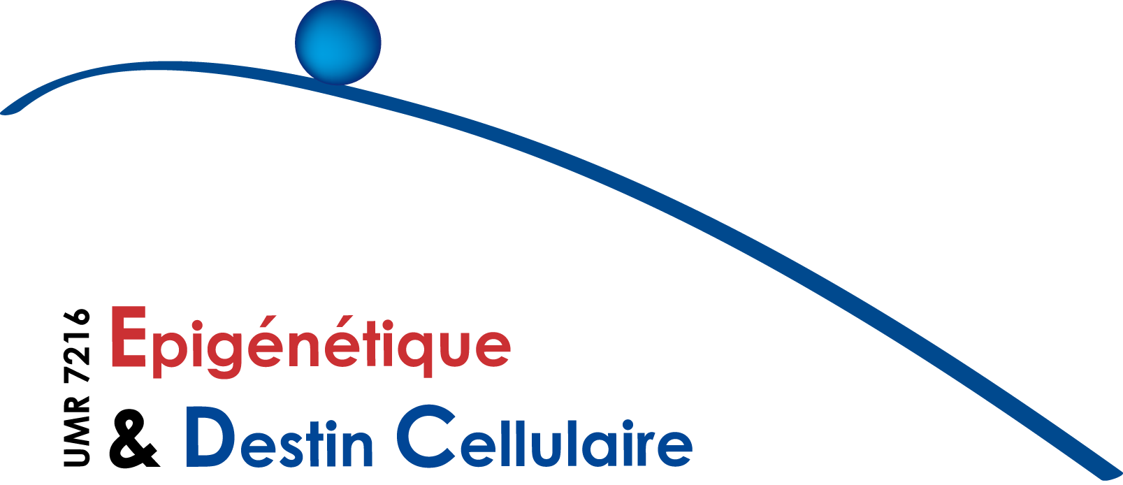

I N F O R M A T I O N S E M I N A I R E E P I G E N E T I Q U E :

Mercredi 16 Mars 2016 à 11h

Sonia Garel
Ecole Normale Superieure, Institut de Biologie (IBENS), Paris
Invité par Valérie Mezger
Early wiring of cortical circuits: neuronal and
immune orchestration

Squarzoni P, Oller G, Hoeffel G, Pont-Lezica L, Rostaing P, Low D, Bessis° A, Ginhoux° F, Garel° S (2014) Microglia modulate wiring of the embryonic forebrain. Cell reports, 8: 1271-9.

Lokmane L, Proville R, Narboux-Nême N, Györy I, Keita M, Mailhes C, Léna C, Gaspar P, Grosschedl R and Garel S (2013) Sensory map transfer to the neocortex relies on pre-target ordering of thalamic axons. Current Biology 23:810-6.

Deck M, Lokmane L, Chauvet S, Mailhes C, Keita M, Niquille M, Lebrand C, Yoshida M, Yoshida Y, Mann F, Grove E, Garel S (2013) Pathfinding of corticothalamic axons relies on a rendezvous with thalamic projections. Neuron 77 :472-84.

Bielle° F, Marcos-Mondejar° P, Leyva-Diaz° E, Lokmane° L, Mire E, Mailhes C, Keita M, Gracia N, Tessier-Lavigne M, Garel* S, Lopez-Bendito* G (2011) Emergent growth cone responses to combinations of Slit1 and Netrin 1 in thalamic axon topography. Current Biology 21:1748-55.

Bielle F, Marcos-Mondejar P, Keita M, Mailhes C, Verney C, Nguyen Ba-Charvet K, Tessier-Lavigne M, Lopez-Bendito G, Garel S (2011) Slit2 activity in the migration of Guidepost neurons shapes thalamic projections during development and evolution. Neuron 69:1085-1098.

Ce séminaire a lieu dans la salle de séminaires de l’Institut Jacques Monod (RB-18B). Bâtiment Buffon - 15 rue Hélène Brion. Paris 13e
Contact : sophie.polo@univ-paris-diderot.fr

Biosketch
Sonia Garel heads the team Brain Development and Plasticity at the Institut de Biologie de l’Ecole Normale Superieure (IBENS) in Paris (France). Her research focuses on understanding the molecular and cellular logic that controls the assembly of forebrain neural circuits during embryogenesis and postnatal development. After earning her PhD in Developmental Biology in University Paris 6 (France, 1999), she completed a three-year post-doctoral stay in UCSF (San Francisco, USA). Subsequently, she became assistant professor at the IBENS. Since 2008, she is heading the team Brain Development and Plasticity. She is a recipient of the European Young Investigator Award (EURYI), the EMBO Young Investigator Program and the ERC consolidator program.

